

**How to Grant Access to another Provider**

* Find the client, scroll down until you can see Access List, click GRANT ACCESS

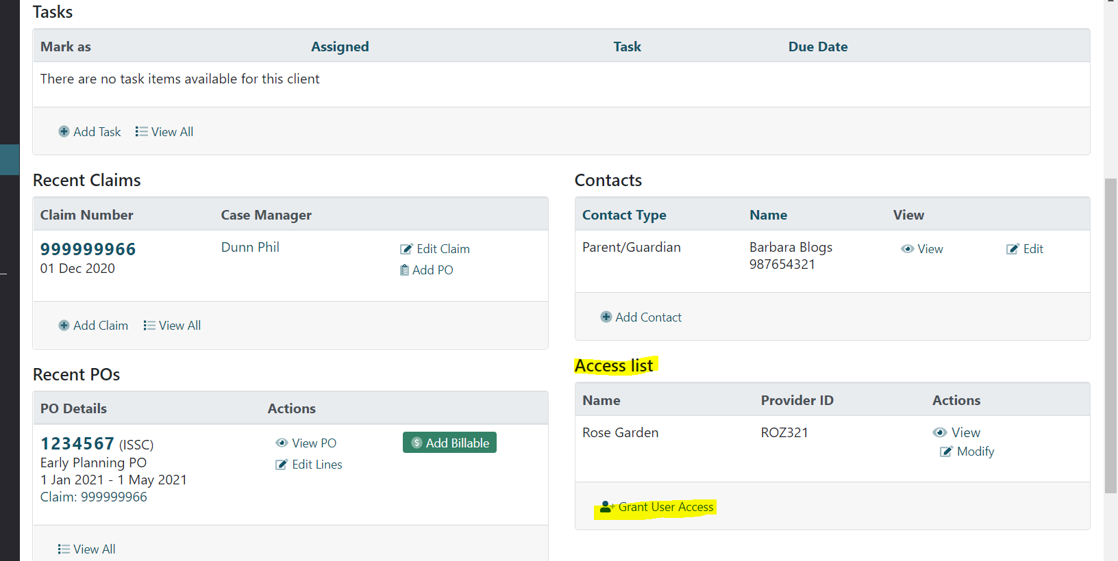

Start typing your provider’s name then click into the dropdown to populate, click ADD ACCESS. Only give your provider the manager role if you want them to be able to edit client details.

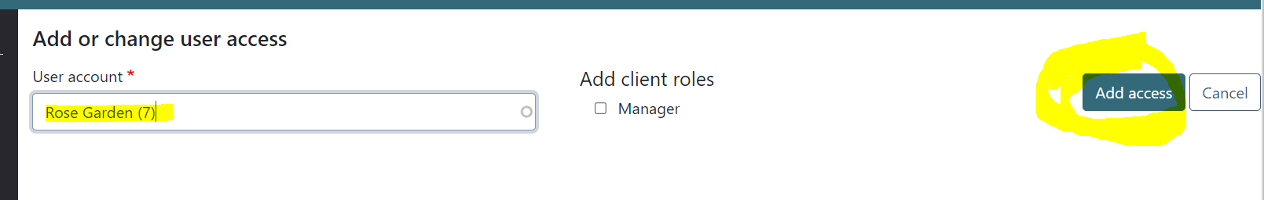

The client will now appear on your provider’s list of clients.