

**How to Add a Contract**

**Go to System Dashboard**

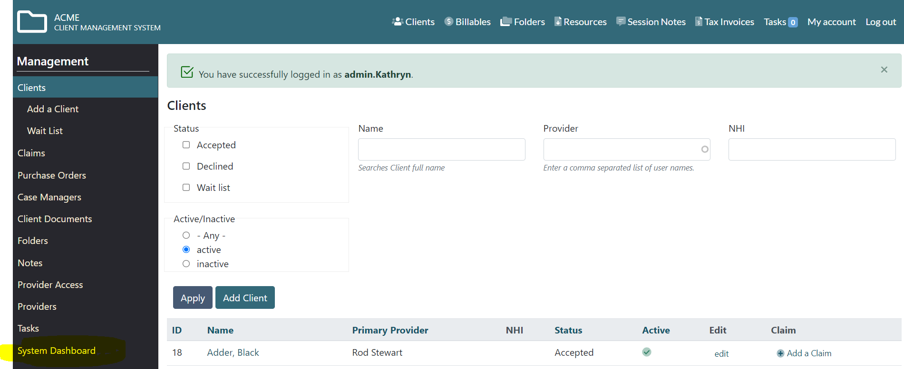

Go to Contracts and Codes – Set up Contracts

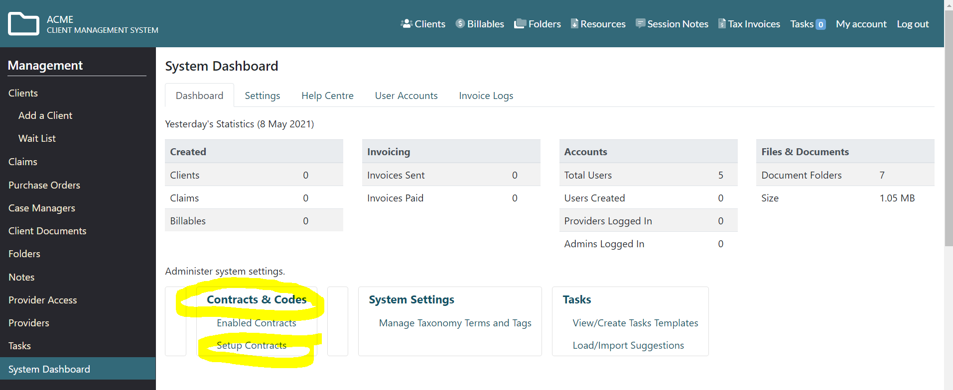

Go to download or synch a contract

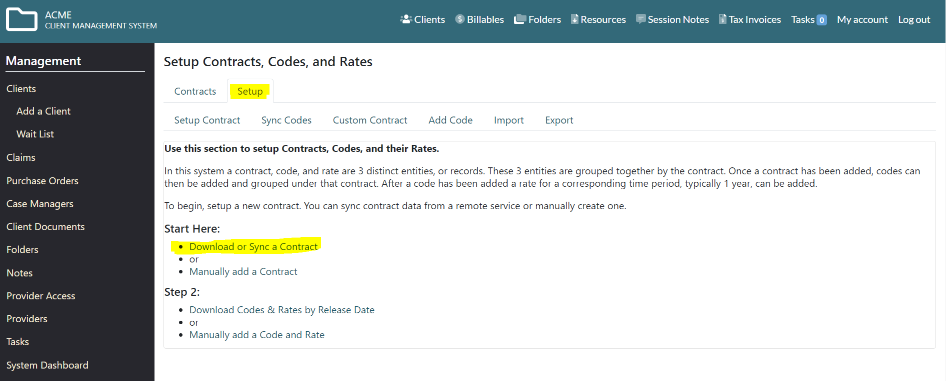

Tick the contract/s you wish to add to your CMS system and download

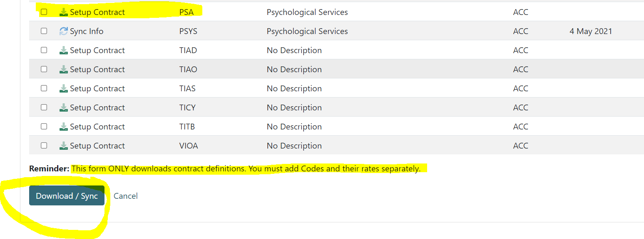

Go to Synch Codes

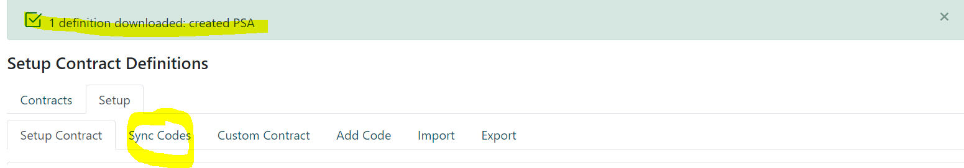

Tick Contract codes to be downloaded

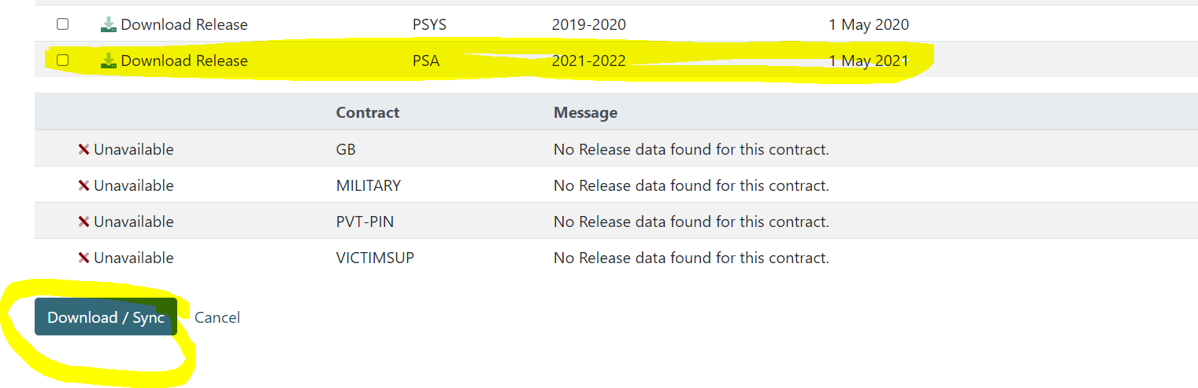

You should then see a message to confirm the codes have been added to your system.

