****

Inactivating and Re-activating Clients

To inactivate a client, choose the client from the list, choose edit and then scroll down to status.

Tick inactive, then save.

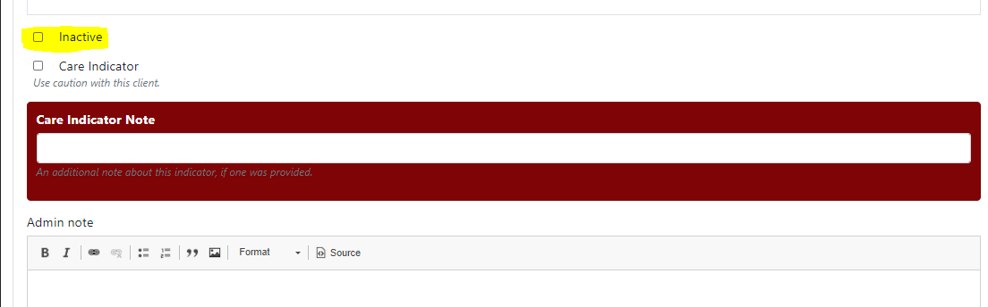

This should NOT be done until all billing has been paid for and updated in CMS as payments for inactive clients will drop into your payment error log.

To reactivate a client, go to your client list, enter client name (first or last, not both), change status to ANY, and APPLY.

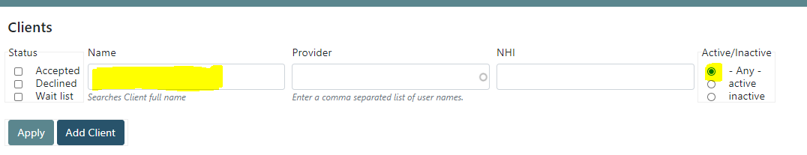

Edit the client and change status to active and save.